**Comparative analyses of SaV GI.1 and SaV GI.2**

**MCMC analysis of Sapovirus G1.1 and G1.2**

**Whole Capsid analysis**

Best subst model for G1.1 is　TN93+G+I followed by🡪 K2+G+I

Best subst model for G1.2 is K2+G with 5 parameters, followed by T92+G+I –> TN93+G🡪 HKY

Testing molecular clock hypothesis: Based on MEGA7 test of MC, we reject Ho, which assumes that SaV G1.1 and G1.2 evolution rate is constant through time and for each different lineage.

Test for evolutionary signal using tempest for G1.1

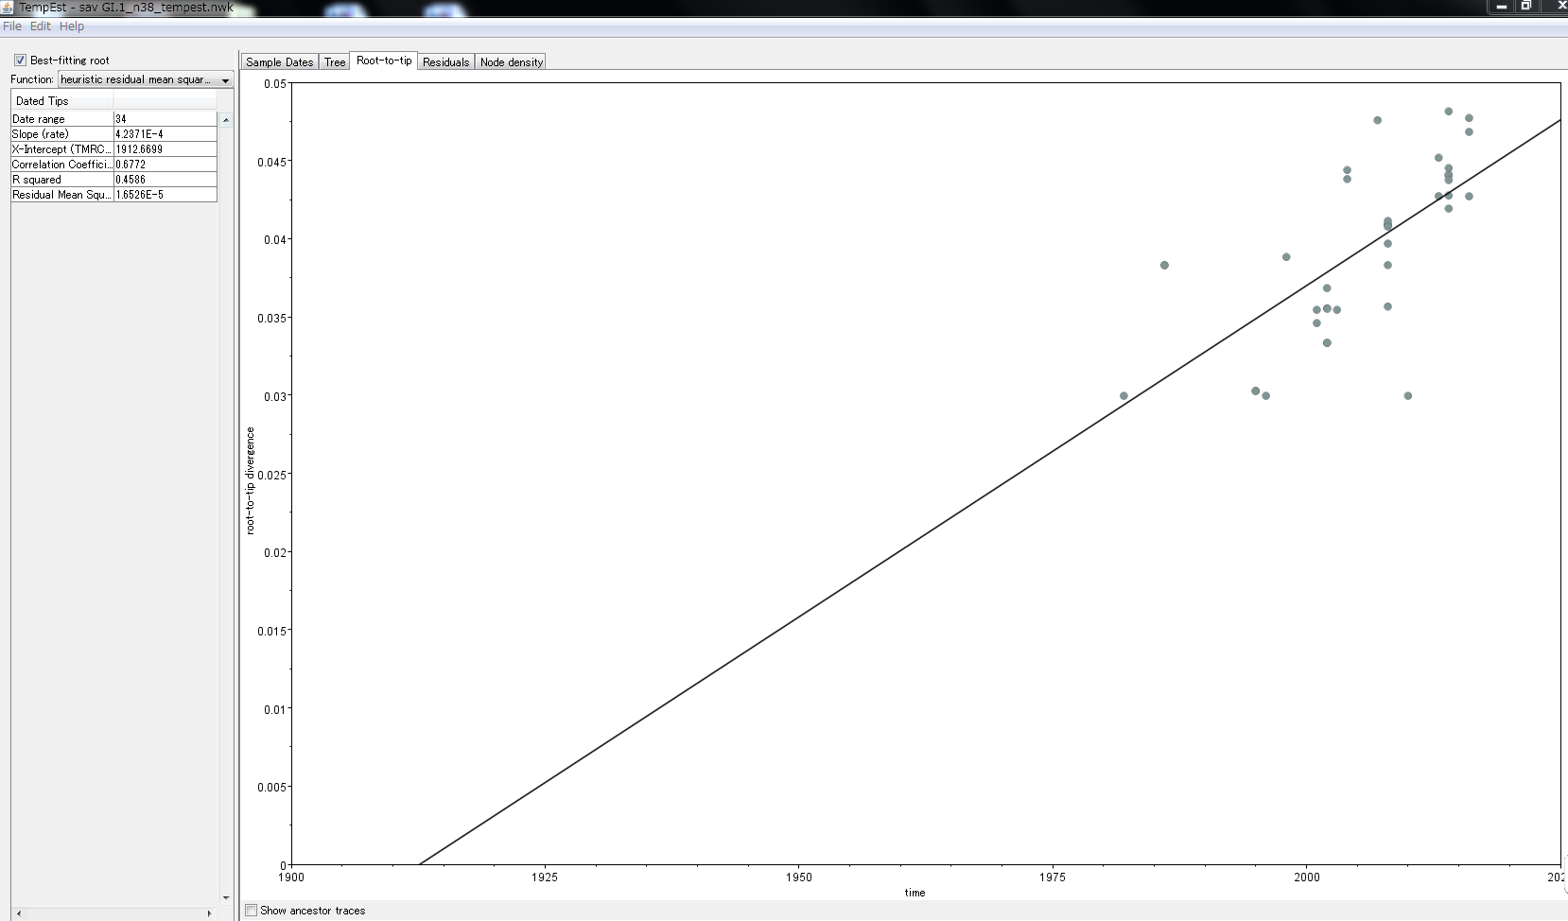

Test for evolutionary signal using tempest for G1.2

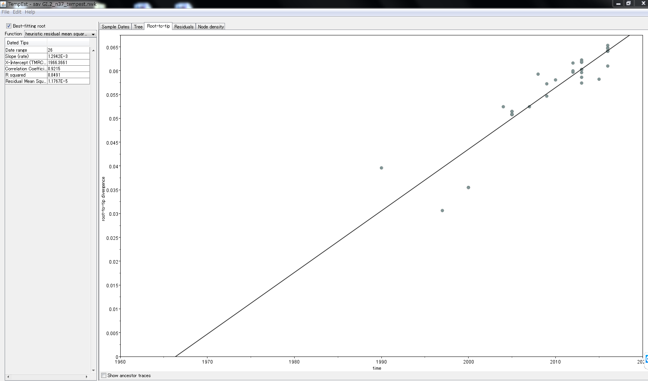

**The plots above show that there are enough evolutionary signals to run MCMC**

Relaxed molecular clock allows the rate of sequence evolution to vary among groups of organisms (or in this case, variants of Sapovirus), or more generally, among different parts of a phylogeny. The use of a single rate across the whole phylogeny is termed strict clock, may be suitable in our case.

**Estimating the average substitution rate using BEAST**

I ran BEAST analysis for G1.1 and for G1.2 capsid datasets

For each SaV GI.2 and GI.1 datasets, substitution rates was estimated using RCE, Strict and RCLN assupmtions.

After model comparison, the strict clock was the best model describing the evolutionary process in both datasets.

**Comparison of mean evolutionary rate of sav G1.1 and SaV GI.2**

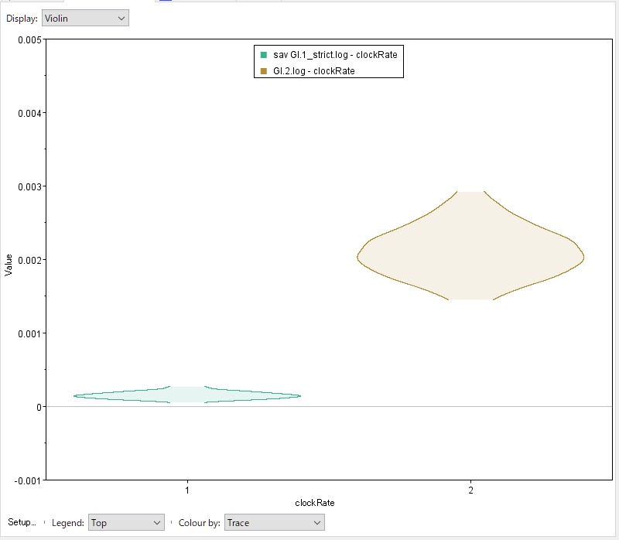

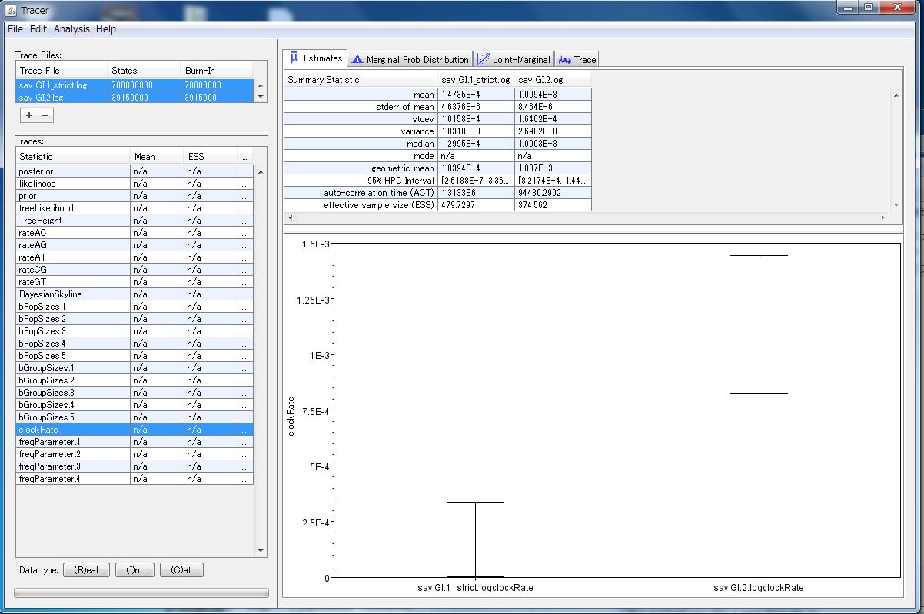

**Results are found here :**

**C:\Users\viro10\Desktop\KTE2_iroiro\SaV G1.1 and G1.2\For capsid\BEAST2\G1.1**

**C:\Users\viro10\Desktop\KTE2_iroiro\SaV G1.1 and G1.2\For capsid\BEAST2\G1.2**